Critical Analysis of Interface (CIDCO Website)
I went through the actual CIDCO website (cidco.maharashtra.gov.in) and checked these issues directly, so these are real, verified issues, not guesses.

Learnability
The homepage has a lot going on at once: a video banner, a quote slider, a dashboard grid, a news ticker, and project cards, all stacked together. A first time visitor doesn't really know where to start.

Usability
Simple tasks take too many clicks. Even the menu itself is confusing "Landmark Projects," "Upcoming Projects," and "Flagship Projects" are three separate menu items, but they all lead to the exact same page with the exact same links underneath.

Consistency
Different sections of the site clearly look like they were built at different times. The homepage cards, the Contact Us page, and the Services tabs all use different styles, spacing, and colours.

Use of Metaphors
Barely any icons are used to help users recognise things quickly. Most of the site is just long lists of text, especially the sitemap.

Navigation Structure
Menus go three or four levels deep in places. And the sitemap, which is supposed to help with this, is itself part of the problem (more on that below).

Visual Hierarchy
Nothing on the homepage clearly stands out as "the thing you should click." Payments, grievances, and housing are all buried at the same visual weight as decorative content.

Accessibility and Dark Mode
The site does have a dark mode toggle, a high contrast mode, and font size controls, which is genuinely good. But it's not applied consistently. I checked the actual CSS and found several places where text and link colours are hardcoded instead of set to change with the theme. For example, some links are set to plain black in the code, so when you switch to dark mode, they stay black on a dark background and become almost unreadable. This happens in more than one section, not just one page, since the same broken styling gets reused across the site.

Navigation Structure Issue: The Sitemap Itself is Broken
This is worth calling out separately. A lot of entries in the sitemap look exactly like clickable links, underlined, styled the same way, but they have no actual link attached in the code. So clicking them does nothing at all, with no error message or warning.

Responsiveness
Mobile works, but feels cramped. Card heavy sections need a lot of scrolling on smaller screens.

Efficiency of Interaction
Getting to an actual service, like paying a water bill or applying for housing, usually means going through a menu, then a tab, then getting redirected to a different website entirely.

Feedback and System Status
The site has success, error, and warning popups built into its code, but they don't consistently show up after real actions like searches or form submissions.

Error Prevention and Recovery
When a sitemap link doesn't work, there's no message telling you it failed. It just silently does nothing.

Aesthetic and Minimalist Design
The homepage tries to show too much at once: banner, carousel, dashboard, ticker, project cards, and a floating payment button, all competing for attention.

Content Readability
Dense text blocks and the dark mode contrast problems mentioned above both hurt readability.

Search and Discoverability
Search only has Web and Image tabs with a basic sort option. No filters by department, date, or document type.

Performance Perception
Pages load fine, but PDF heavy notices and redirects to outside payment sites make things feel slower and occasionally less trustworthy, since the browser suddenly jumps to an unfamiliar domain or port with no warning.

Trust and Credibility
Being a government site gives it some built in trust, but that trust takes a hit from dead sitemap links, inconsistent dark mode, and payment links that bounce between several different domains, and sometimes even raw IP addresses, with no explanation.

Personalization
No saved preferences, no personal dashboard, no history of what you last looked at.

User Satisfaction
People can eventually get what they need, but only after dealing with broken links, inconsistent styling, and a housing section that's scattered across four different places.

Specific Real Bugs Found (Verified)
- In dark mode, some links stay black instead of adjusting colour, because they're hardcoded in the CSS rather than tied to the theme.
- On the Contact Us page, only 2 out of 9 listed offices have a working "View on Map" link.
- The sitemap has many entries with no actual link attached, so they look clickable but aren't.
- Hovering over cards highlights the whole card instead of just the link inside it. This happens on the Services section and the Projects section too, not just Marketing.
- The floating payment button is positioned partly off screen on purpose in the code, and it shifts depending on whether English or Marathi is selected. That's likely why it looks like it's touching the edge.
- Housing information is split across four different places: a Marketing page, a PMAY page, a Development Plan page, and a separate website (cidcohomes.com) entirely.
- The "Landmark," "Upcoming," and "Flagship" Projects menu items all lead to the same content, just under different names.
- Payment and service links send users to several different domains, subdomains, and sometimes raw IP addresses, with no warning that they're leaving the main site.
- Even after picking a language, some menu labels still show both English and Marathi together.
- The "last updated" date and visitor counter are shown in tiny text at the very bottom of the page, so almost nobody notices them.

Parameter Table

Parameter | Rating | Observation
Learnability | 3/10 | Homepage is crowded, no clear starting point
Usability | 3/10 | Simple tasks need many clicks, menu has duplicate entries
Consistency | 3/10 | Different sections look like different websites
Use of Metaphors | 3/10 | Very few icons, mostly plain text
Navigation Structure | 2/10 | Deep menus, and the sitemap itself has broken links
Visual Hierarchy | 3/10 | No clear priority action on the homepage
Accessibility | 2/10 | Dark mode exists but breaks in several places due to hardcoded colours
Responsiveness | 3/10 | Works on mobile but feels cramped
Efficiency of Interaction | 3/10 | Reaching a service takes multiple steps plus a redirect
Feedback and System Status | 3/10 | Popups exist in code but aren't consistently shown
Error Prevention and Recovery | 2/10 | Broken links fail with zero explanation
Aesthetic and Minimalist Design | 3/10 | Too many sections competing for attention
Content Readability | 3/10 | Dense text plus dark mode contrast issues
Search and Discoverability | 3/10 | Basic search, no real filters
Performance Perception | 4/10 | Loads okay, feels slower due to PDFs and redirects
Trust and Credibility | 4/10 | Government backing helps, but dead links and odd domains hurt it
Personalization | 2/10 | No saved preferences or personal dashboard
User Satisfaction | 3/10 | Tasks are possible, but frustrating to get through

Golden Rules (Shneiderman)
- Strive for Consistency: Some parts of the site use theme colours properly, others hardcode fixed colours, so dark mode breaks unevenly across the site.
- Seek Universal Usability: Small text and low contrast in dark mode make it harder for elderly or visually impaired users, even though accessibility controls exist.
- Offer Informative Feedback: Clicking a dead sitemap link gives no response at all, so users can't tell if it's broken or just loading.
- Design Dialogs to Yield Closure: Payments redirect to outside sites with no clear confirmation that the action actually went through.
- Prevent Errors: Sitemap links that look real but go nowhere are a direct example of this rule being broken.
- Permit Easy Reversal of Actions: There's no easy way to back out of a search or filter once you're in it.
- Keep Users in Control: Auto scrolling banners and tickers move at their own pace instead of the user's.
- Reduce Short Term Memory Load: With housing spread across four different places, users have to remember where they last saw what they needed.

Summary of Problems
- Crowded homepage with no clear priority
- Sitemap has many dead, non working links
- Dark mode is inconsistent, some text and links don't adapt and become unreadable
- Only 2 of 9 offices have a working map link
- Hover effects highlight whole cards instead of the actual clickable link, across multiple sections
- The floating payment button sits partly off screen and shifts by language
- Housing information has no single clear entry point
- Duplicate menu items lead to the same page
- Payment links jump across several unrelated domains with no warning
- Heavy reliance on PDFs instead of readable web pages
- Basic search with no real filtering

Recommendations
- Fix the sitemap first: every link should either go somewhere or be removed
- Apply theme colours consistently everywhere so dark mode actually works across the whole site
- Add map links for all 9 offices, not just 2
- Make hover effects apply only to the actual clickable link, not the whole card
- Create one clear, single Housing section instead of scattering it across four places
- Remove the duplicate Projects menu entries
- Reposition the floating payment button so it's fully visible and stays consistent across languages
- Add a simple notice before redirecting users to outside payment sites
- Add real filters to search, and use responsive web pages instead of PDFs for important notices
- Simplify the homepage by giving Payments, Grievances, Housing, and Tenders clear visual priority

My notes:
for cidco add issues real like
when switched to dark mode the links are still black instead of blue gives visibility issue
on contact us page the view map feature is only for 2 offices
on sitemap page the readability is in dark blue which is not properly visible
The payment button
English marathi button is touching the boundary line
On the marketing page when i hover over a component the hover effect works on the whole component instead of the link that redirects to the desired page
Too much information on the site
If one want to look for housing there is no proper way to access it
At a lot of the places the links in dark more are in dark color only which causes the readability issues
On a lot of the pages when switched to dark mode the content still retains the dark text color which causes a readability issues
Unable to change language when you scroll down (no stick navbar support)

Links not properly visible on a lot of pages in dark mode causing readability issues:
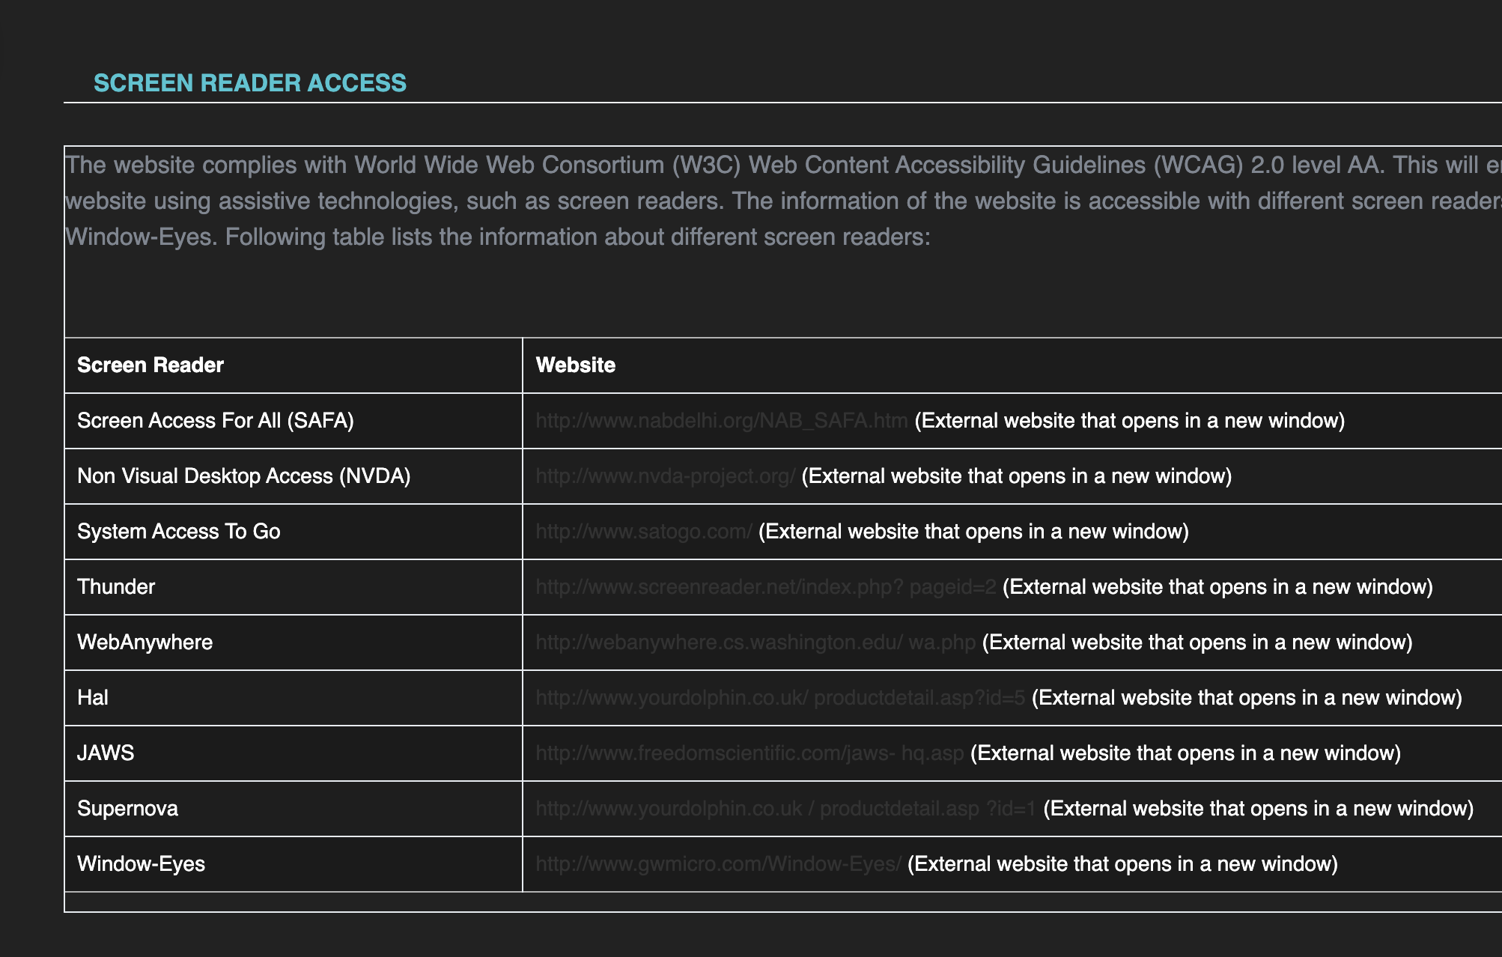
on contact us page the view map feature is only for 2 offices :
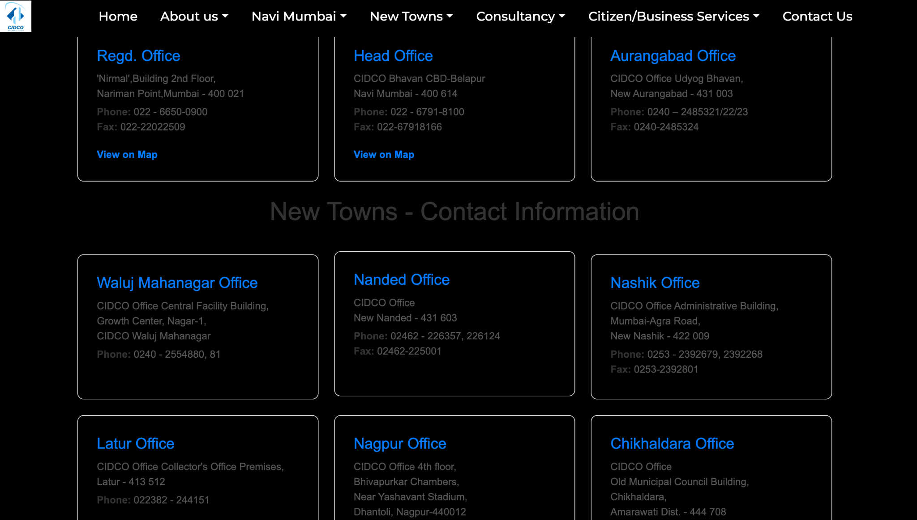
Unnecessary info in hero section , no proper flow to buy properties :
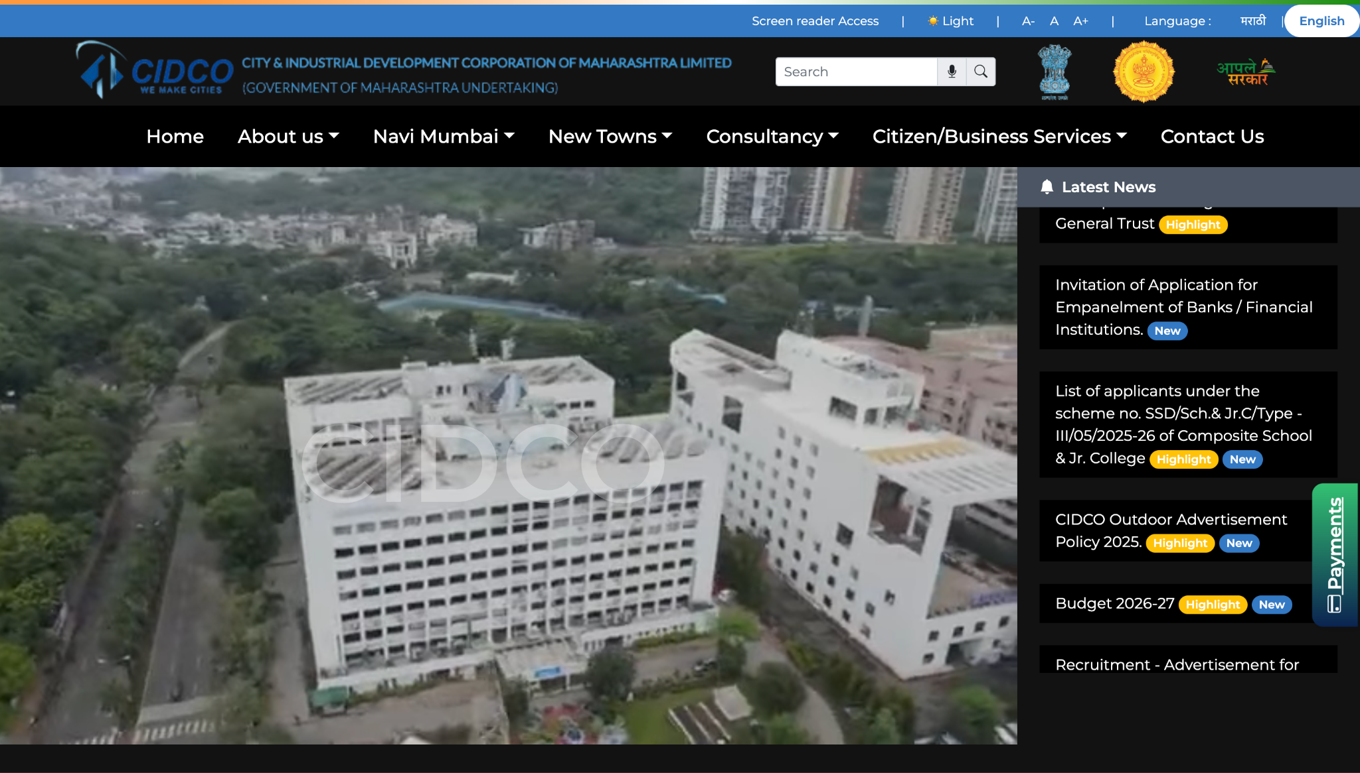
Unnecessary payments button issues floating and distracting :
